**RESUME** 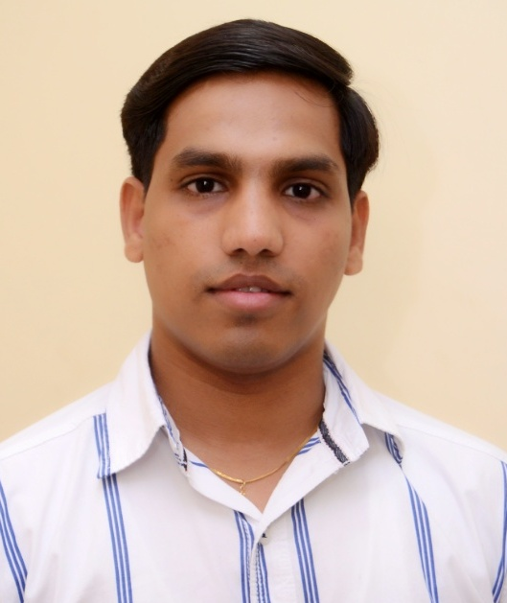

**Sushil Pandurang Shirvandekar.**

A/001, KMC PARK,

Narangi Road, Opp Paras Hospital,

Virar East- 401303.

Mobile No.:-9325942432/8698934670

Email: sushilghadi25@gmail.com

## **PROFESSIONAL PROFILE**

Working with ANANYA ENTERPRISE (Parle Biscuits Distributor) As a Billing Executive.

* **Entry of Purchase bills**
* **Prepare sales Invoice**
* **Maintain Stock Record**
* **Bank Recipet Entries**

Worked With **PHENOMENAL KNOWLEDGE CITY PVT. LTD.** As a Sr. Executive.

From 2006 - 2016**.**

* **Client Handling**
* **Handling Branch Issues.**
* **Document Requirement Correspondence with Member / Branch.**
* **Solve Queries of Client regarding Refund.**
* Document checking of False Mediclaim.
* **Financial Year ending reports.**

Worked with SNK Corporation as a Back Office Executive for 2 years in the year 2004-2005.

* **Client Handling**
* **Convincing client for New policy**
* **Correspondence with Agents.**
* **Policy verification, Insurance Claims, Claims Processing.**

u

## **OBJECTIVE**

I am now looking to progress into a Good position within the Administration sector. I am therefore keen to find a new and suitably challenging role within a Administration field.

## **EDUCATION AND QUALIFICATIONS**

* **S.S.C.** From Mumbai State Board.
* **H.S.C.** From Mumbai State Board.
* T.Y.B.com Mumbai University

.

## **KEY I.T. SKILLS**

Computer Knowledge (MS Excel, MS Word,)

## **PERSONAL DETAILS**

# Date of Birth **:** 19th Oct 1982

# Born Place : Mumbai

Yours Faithfully,

**(Sushil P. Shirvandekar)**